2019-20 INCOME VERIFICATION
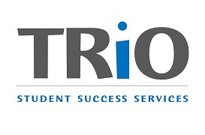

SOUTH SEATTLE COLLEGE - TRIO STUDENT SUCCESS SERVICES PROGRAM

As a federally funded TRIO program, TRIO-SSS is required to provide documentation of your eligibility for our program to the U.S. Department of Education in order to meet TRIO regulations that two-thirds of the students in our program meet federal low-income guidelines.
NAME___________________________________________________ SID
You must complete this form, whether or not you believe you qualify as low-income.
Plan select your status for the 2018 tax year:
I was an Independent Student (meet 1 or more criteria below)
- I was born before 1/1/96
- I am married
- I have child(ren) or dependent(s) that I support (more than ½)
- I am an emancipated minor
- I am/was an orphan, foster youth, or ward of the court
- I am a veteran or active service member
- The Financial Aid Office has made determination that you are independent
OR
I was a Dependent Student (do not meet Independent criteria).
Please circle family size & TAXABLE income:
2018 Income & Family Size
Please circle your family size & TAXABLE Income level* level:
*Taxable Income is found on IRS tax form #1040 – line 10
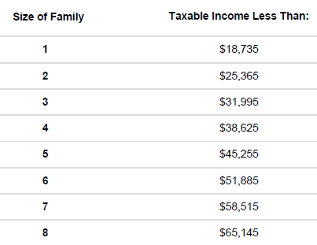
For families with more than 8 members, please indicate family size ________.
Add $6,630 per additional member for taxable income level: $_________________

OR I did not file a tax return last year because my income was less than required to file.
__________________________________________________________  Independent Student Name – please print  __________________________________________________________  ^{Independent Student Signature}  _______________________________  ^{Date} | __________________________________________________________  Dependent Student’s Parent/Guardian Name – please print  _____________________________________________________________  ^{Parent/Guardian Signature}  ________________________________  ^{Date}

