Interdepartmental Charge/Expense Transfers in ctcLink
Review the EXAMPLES listed below for operating funds and follow the pattern to create an IDC

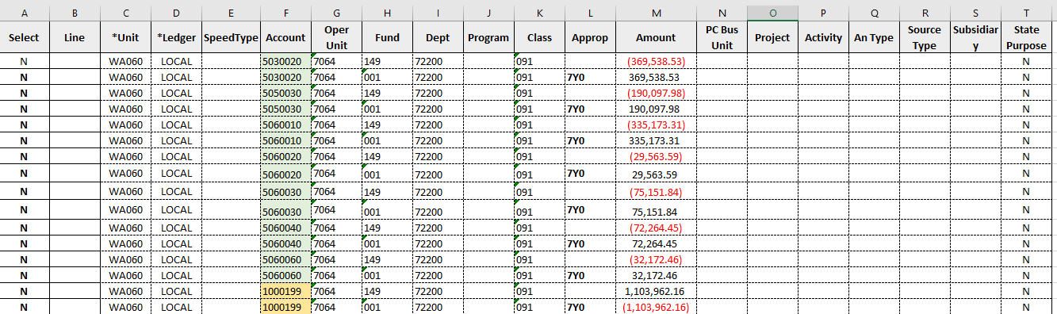

- The examples above are for expenditure transfers. The first transfer is within the same fund so the 10000199 cash transfer is not necessary. The second transfer is between two funds/appropriations and therefore needs to have the cash transfer to off set the move between funds.
- The second tab provides detail back up or explanation for the transfer.
- Once the IDC is completely filled out, send to the Business Office email at SouthBusinessOfc@seattlecolleges.edu
- The Business Office will review for accuracy and approve or return for further information.
- Once the IDC is approved, the Business Office will send to the District Office to complete the expense transfer process.

