CREATING ACCESSIBLE DOCUMENTS IN MICROSOFT WORD

ANGELA PAK
DISABILITY SERVICES, PROGRAM COORDINATOR

Definition of Accessibility

Accessibility –
“...individuals with disabilities are able to independently acquire the same information, engage in the same interactions, and enjoy the same services within the same timeframe as individuals without disabilities...”
(Penn State Settlement)

What is a document?
- A piece of written, printed, or electronic matter that provides information or evidence or that serves as an official record
(Google, July 2013)
- Electronic documents include Word, PDF, PowerPoint, etc.

Core Principles
Following the core principles and practicing the basic steps to implement them are necessary in order to create an accessible document on Word
- Headings
- Lists
- Alternative text for images
- Tables
- Language
- Descriptive Hyperlinks
- Check accessibility

Headings
- Headings are important because they provide an outline of the document and also help users understand how the document is organized
- Users are able to navigate more efficiently through the document with headings when using assistive technologies like screen readers

Headings
- You can find headings in the Styles section of the Home ribbon in Word
- Keep headings cascading, hierarchical
- Large text, bold, italics, etc. do not make it a heading
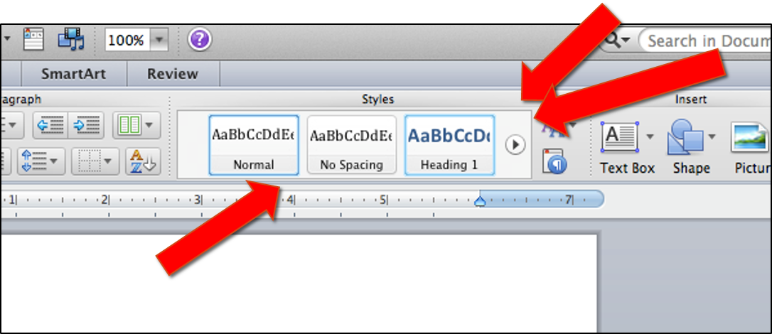

Lists
- Lists (word-formatted numbered or bulleted) provide structural information to users of screen readers
- Without using these tools, a screen reader is unable to fully understand the context, and a list is not really a list
- You can find lists in the Paragraph section of the Home ribbon in Word
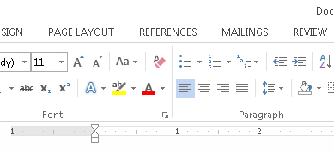

Add Alternative Text for Images
- Adding alternative text provides a text description for images charts, graphs, and tables; creates access to information included in visuals for individuals with visual disabilities
- The alt text should be succinct and to the point

“Cow in a meadow”

Add Alternative Text for Images
- How do I do it?
  - Right click on imageSelect Format Pictureenter appropriate description of the image

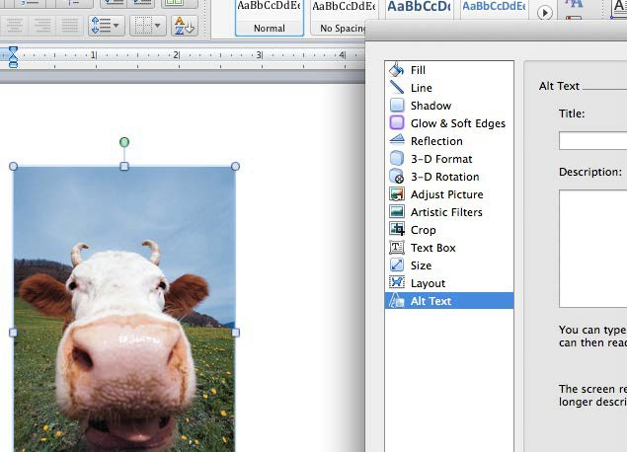

Tables
- Tables are used for communicating relationship between data, not for formatting
- Tables are difficult for screen reader users to understand unless the relationship between all parts of the table is explicitly defined
- Simple tables with one row of column headers and no nested row or columns can be made accessible on Word; however, complex tables cannot and may need to be simplified to make them accessible

Tables
- Where do I start?
  - Select the row that contains the column headers and right-clickTable propertiesRowcheck the checkbox “Repeat as header row at the top of each page”
Course | Midterm | Final
Biology | 92% | 95%
Calculus | 91% | 92%
Ceramics | 94% | 95%
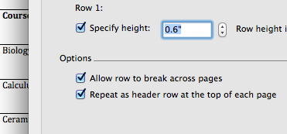

Tables
- Create an alt text for the table by selecting the tableRight click on tableSelect Format PictureEnter appropriate description of the table

Language
- Identifying the default language provides information to speech synthesizer
- If other parts of the document are in a different language, it is important to identify each language

Language
- How do I set the language?
  - FileOptionsLanguage
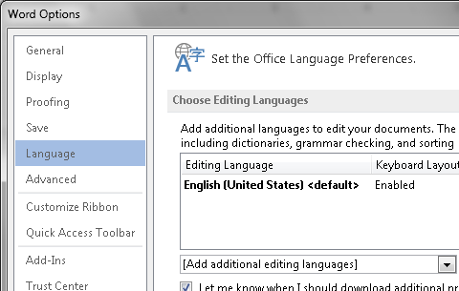
Descriptive Hyperlinks
- Hyperlink text should describe the destination of the link
- Example of inaccessible hyperlink:
“For more information, please click https://docs.google.com/document/d/1XSELtR0mjCVQu0L2Voj_YGmqZpy9m MRH8qfranCFQPI/edit?usp=sharing”
- Example of a more accessible hyperlink:
“For more information, please click here”

Descriptive Hyperlinks
- How do I format a link?
  - Right click hyperlinkEdit hyperlinkText to display

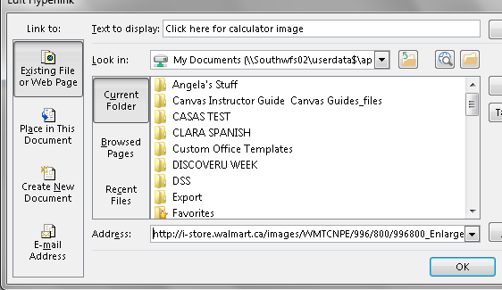
Check Accessibility
- The Accessibility Checker can help to find common accessibility errors in a Word document
  - FileInfoInspect DocumentCheck Accessibility
Resources
- http://www.washington.edu/accessibility
- http://webaccess.msu.edu/Tutorials/word-windows.html
- http://accessibility.psu.edu/microsoftoffice/microsoftword/
- www.lynda.com
- Resources from Accessibility Retreat 2015

