CIC and ACAS Course Origination Template

Please read the CIC and ACAS Guide for Originating a Course before completing all the sections of this template. After saving your work, copy/paste it to the actual ACAS course outline for submission.

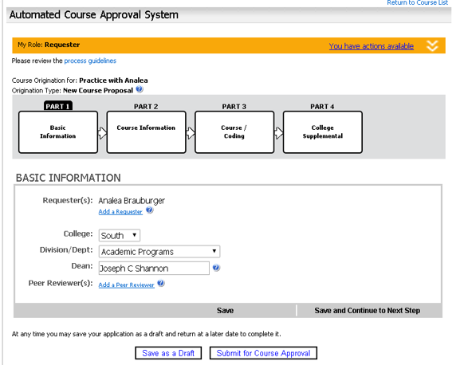

Requester:
Add a Requester (list them):
College: South
Division/Dept.:
Dean:
Peer Reviewer(s):

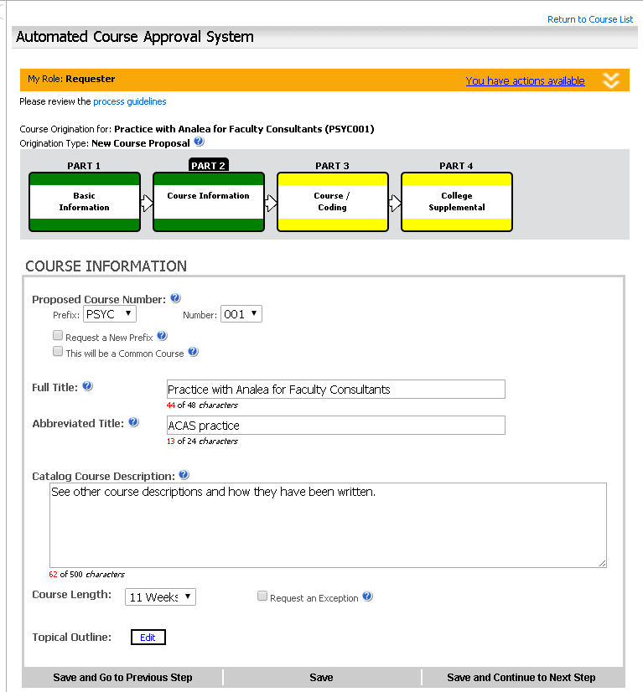
Prefix:
Number:
Full Title (48 char. max):
Abbreviated title (24 char. max):
Catalog Course Description (550 char. max):
Course Length:

Topical Outline:

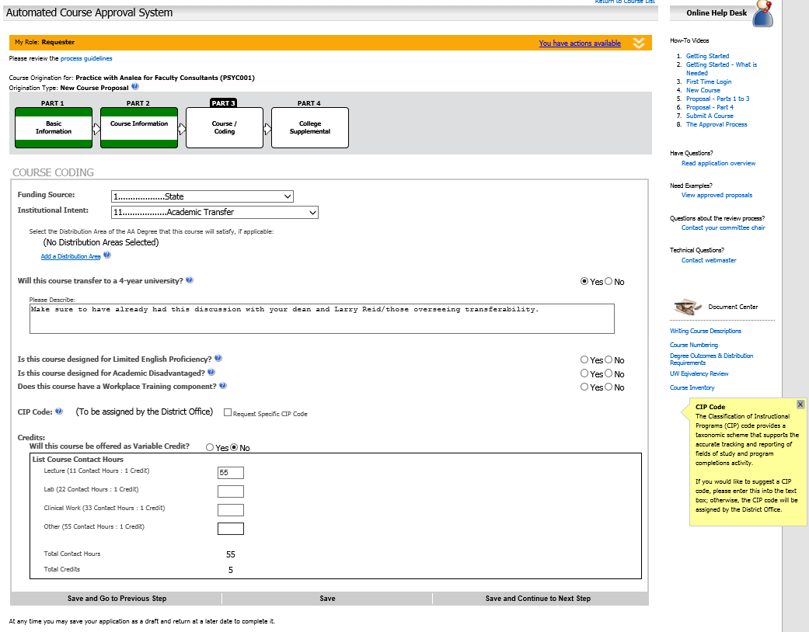
Please describe how course will transfer to a 4-year university:
Course Contact Hours:
Lecture:
Lab:
Clinical Work:
Other:
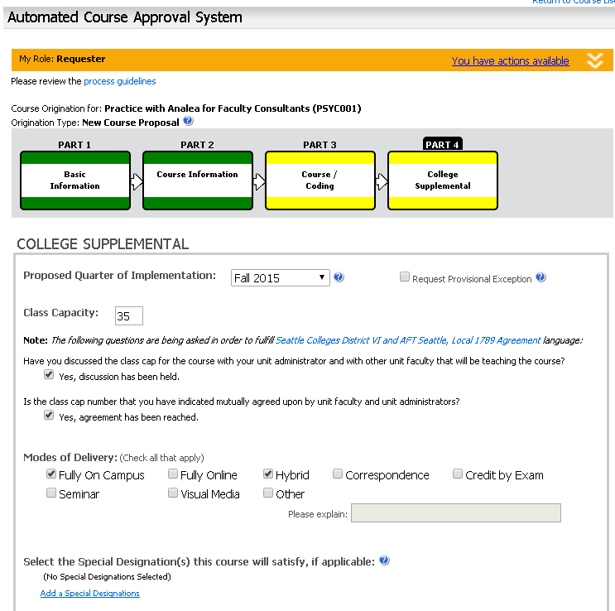
Proposed Quarter of Implementation:
Class Capacity:
Mode(s) of Delivery:

Special Designation(s):
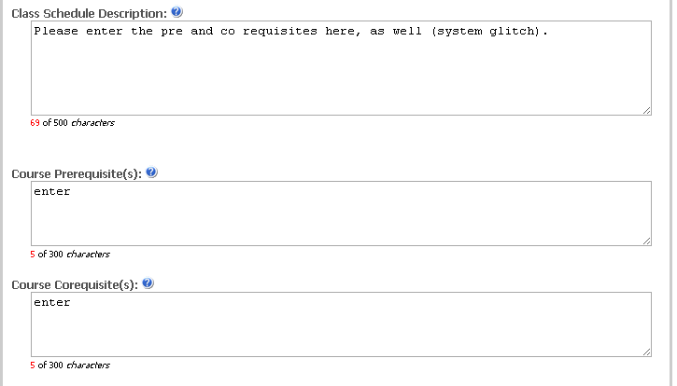
Class Schedule Description:
Course Prerequisite(s):
Course Corequisite(s):
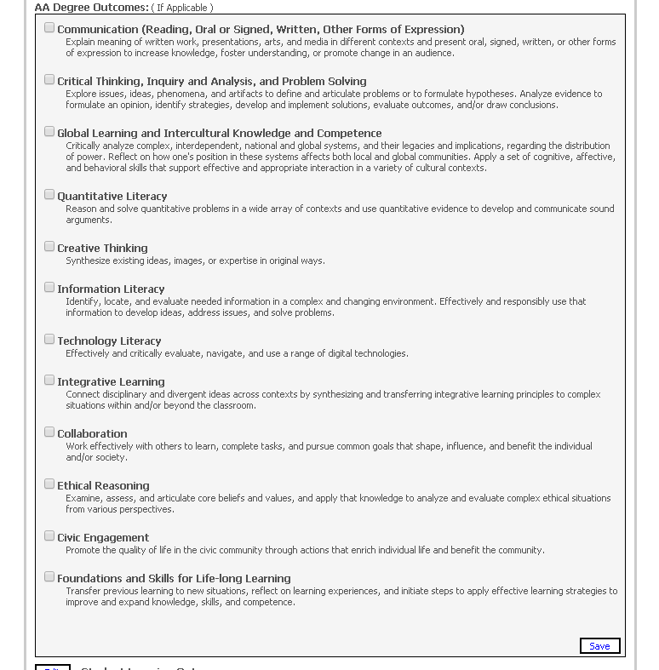
Academic Programs requesters only: Select the AA Degree outcomes addressed by your course and list below.
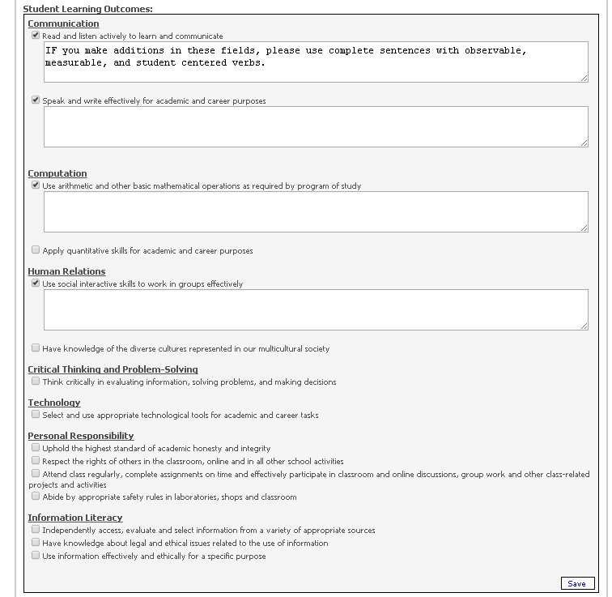
All requesters:
(1) Choose the SLOs addressed by your course by checking the appropriate boxes.
(2) Optional but highly recommended: Describe a specific example of how each outcome is measured in your course. Use complete sentences with observable, measurable, and student-centered verbs. Again, provide examples that reflect all sections of the course—not just your own. Save each text entry below.

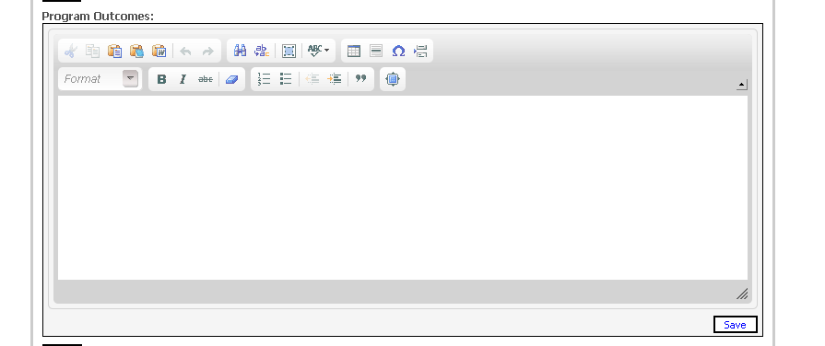
(Part #1) All requesters: Link your course outcomes to the SLOs on the chart below and copy/paste it into the Program Outcomes window on the ACAS course outline. Please retain all SLOs on the chart, whether or not your course addresses them.
SLO  # | Included in  Course Objective  Number | SSC Student Learning Outcomes
SLO 1.1 |  | Communication - Read and listen actively to learn and communicate.
SLO 1.2 |  | Communication - Speak and write effectively for academic and career purposes.
SLO 2.1 |  | Computation - Use arithmetic and other basic mathematical operations as required by program of study.
SLO 2.2 |  | Computation - Apply quantitative skills for academic and career purposes.
SLO 3.1 |  | Human Relations - Use social skills to work in groups effectively.
SLO 3.2 |  | Human Relations – Have knowledge of the diverse cultures represented in our multicultural society.
SLO 4.1 |  | Critical Thinking—Think critically in evaluating information, solving problems, and making decisions.
SLO 5.1 |  | Technology - Select and use appropriate technological tools for academic and career tasks.
SLO 6.1 |  | Personal Responsibility – Uphold the highest standards of academic honesty and integrity.
SLO 6.2 |  | Personal Responsibility – Respect the rights of others in the classroom, online, and in all other school activities.
SLO 6.3 |  | Personal Responsibility – Attend class regularly, complete assignments on time, and effectively participate in classroom and online discussions, group work, and other class-related projects and activities.
SLO 6.4 |  | Personal Responsibility – Abide by appropriate safety rules in laboratories, shops, and classrooms.
SLO 7.1 |  | Information Literacy—Independently access, evaluate, and select information from a variety of appropriate sources.
SLO 7.2 |  | Information Literacy – Have knowledge about legal and ethical issues related to the use of information
SLO 7.3 |  | Information Literacy - Use information effectively and ethically for a specific purpose.

(Part #2) All requesters except those from Academic Programs: Also, create a chart on which you link your course outcomes to your program outcomes. Please include all program outcomes on your chart, whether or not your course addresses them. Copy/paste this chart to the Program Outcomes window beneath the SSC SLOs chart.
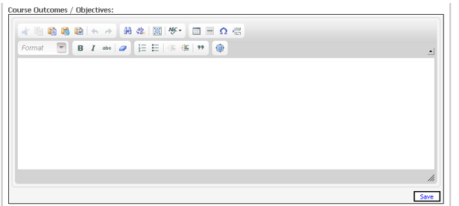

All requesters: List your course outcomes and preface them with the following: “Upon successful completion of this course, students will be able to.”

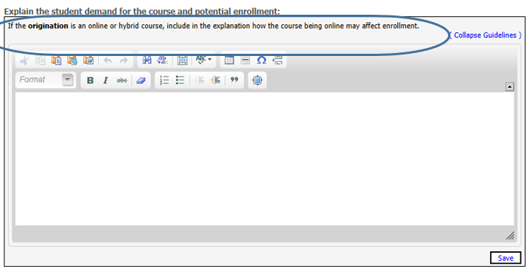
Explain the student demand for the course and potential enrollment. If the origination is an online or hybrid course, include in the explanation how the course being online may affect enrollment.
Explanation:

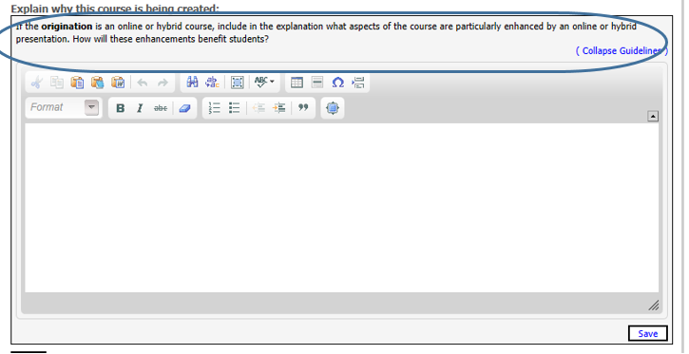

Explain why this course is being created. If the origination is an online or hybrid course, include in the explanation what aspects of the course are particularly enhanced by an online or hybrid presentation. How will these enhancements benefit students?
Explanation:

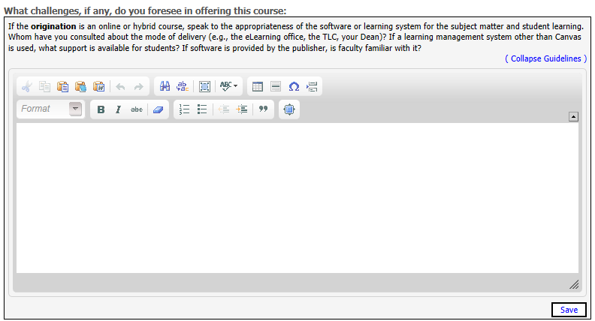

What challenges, if any, do you foresee in offering this course? If the origination is an online or hybrid course, speak to the appropriateness of the software and learning system for the subject matter and student learning. Whom have you consulted about the mode of delivery (e.g., the eLearning office, the TLC, your Dean)? If a learning management system other than Canvas is used, what support is available for students? If software is provided by the publisher, is the faculty familiar with it?
Explanation:

Notations: Field to add any notes about course fees, permissions, or any other information as needed. If none, state “none.”

